Query the list of CITY names from **STATION** that do not start with vowels. Your result cannot contain duplicates.

**Input Format**

The **STATION** table is described as follows:

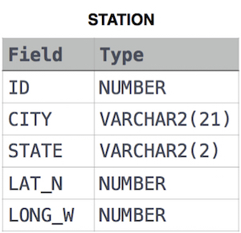

where LAT_N is the northern latitude and LONG_W is the western longitude.

Ans:

select distinct CITY from STATION where

city not like 'A%' and

city not like 'E%' and

city not like 'I%' and

city not like 'O%' and

city not like 'U%';